**Cancelling an electronic prescription**

**Reminder - when medications are cancelled on EMIS, notifications that appear in the yellow banner on the EMIS screen must be acted on appropriately.**

* To cancel a medication or item on EMIS, highlight the item that requires cancelling and select the cancel issue option from the EMIS ribbon. A box entitled cancel issues will then appear. Select a reason for the cancellationfrom the drop-down options and then click OK.

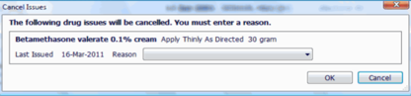

* If the medication is to be discontinued it may also be appropriate at this point to select the option from the EMIS ribbon to end the course. The medication or item will then be archived within past drugs with the reason for the cancellation displayed alongside.
* If the prescription is still **on the NHS spine**, it will be available for an automatic cancellation and a **successful** cancellation notification will appear in the yellow ribbon which appears across the patient’s EMIS screen. In this scenario **no further action is required** by the practice.
* If the prescription **has already been downloaded** from the spine by the pharmacy team, it will notbe available for an automatic cancellation and an **unsuccessful** cancellation notification will appear in the yellow ribbon across the patient’s EMIS screen. If this occurs **further action is required** by the practice.
* This unsuccessful cancellation notification can appear in **two** scenarios: if the pharmacy team has downloaded the prescription and is pending dispensing, **or** if the prescription has been dispensed by the pharmacy team and is now with the patient.
* In both scenarios, **it is the responsibility of the surgery team to contact the pharmacy team.** If the prescription has been downloaded but is not yet with the patient, please request that the pharmacy team return the prescription to the spine.
* Once the pharmacy team have been notified of the prescription cancellation and have returned the prescription to the spine, the rejected prescription should be found by selecting workflow manager. The rejected prescription is located in the EPS rejections section of the Medicines Management tab within workflow manager.

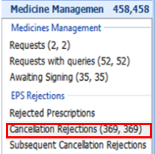

* By selecting the appropriate prescription to be cancelled within cancellation rejections the option to **mark as cancelled** can then be selected to manually cancel the prescription.

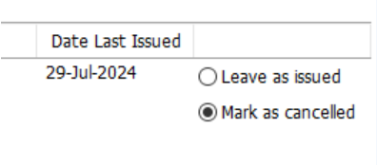

* If the prescription has been dispensed by the pharmacy team and is now with the patient, the prescription **must not be cancelled** at this stage, as this will result in an inaccurate removal of the medication issue from the patient’s medication history and will not appear to have been dispensed by the pharmacy team, nor received by the patient. Again the rejected prescription can be found within the Medicines Management tab within workflow manager and the option to **leave as issued** should be selected.
* In this scenario, **it is the responsibility of the surgery team to contact the patient** to ensure that they are aware that the medication is to be discontinued and a consultation added to the patient medication record to explain this, and if appropriate, to end the course with a reason included.

**If notifications are not acted on by the surgery team, and pharmacies are not contacted this could result in real consequences for a patient. This could include prescriptions being dispensed, given to patients and claimed for payment when the GP practice team think they have been cancelled. This is avoidable – if you amend or cancel a prescription and you receive a notification asking you to contact the dispenser you must do so.**